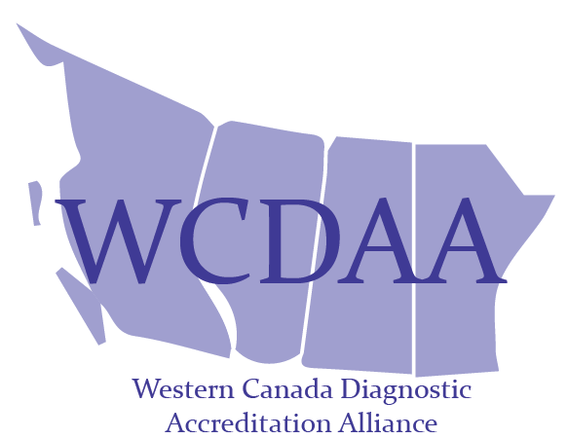
Laboratory Standards Copyright/Reference Permission Request
College of Physicians & Surgeons of Alberta (CPSA) accredited laboratories and other approved users may download, print or make a copy of this material for their noncommercial personal use. Any other reproduction in whole or in part requires written permission from the CPSA and the material must be credited to the CPSA.
To receive permission to reproduce/reference all or part of the Laboratory Standards, please complete the following form. To help us process your request in the timeliest manner possible, please be sure that the information you provide is both accurate and complete.
Name:
Title:
Facility/Organization:
Phone #:
Email:
Date:
Name of Standards Document:
Standard #/Standard Section #/Reference Name:
Provide all relevant details, including the purpose for the request, the publication name, and the targeted audience (attach copy of proposed verbiage):

For submission e-mail to: laurel.wilson-perry@cpsa.ab.ca
For Internal Use only
Authorization:

Ms. Liz McBride, Program Manager, Laboratory Accreditation Services Date

